Problem with planned start date being random date still occurring.

In the example
Copied an activity to create activity #??
Then changed the status of recorded- not started and saved with auto planning switched on.
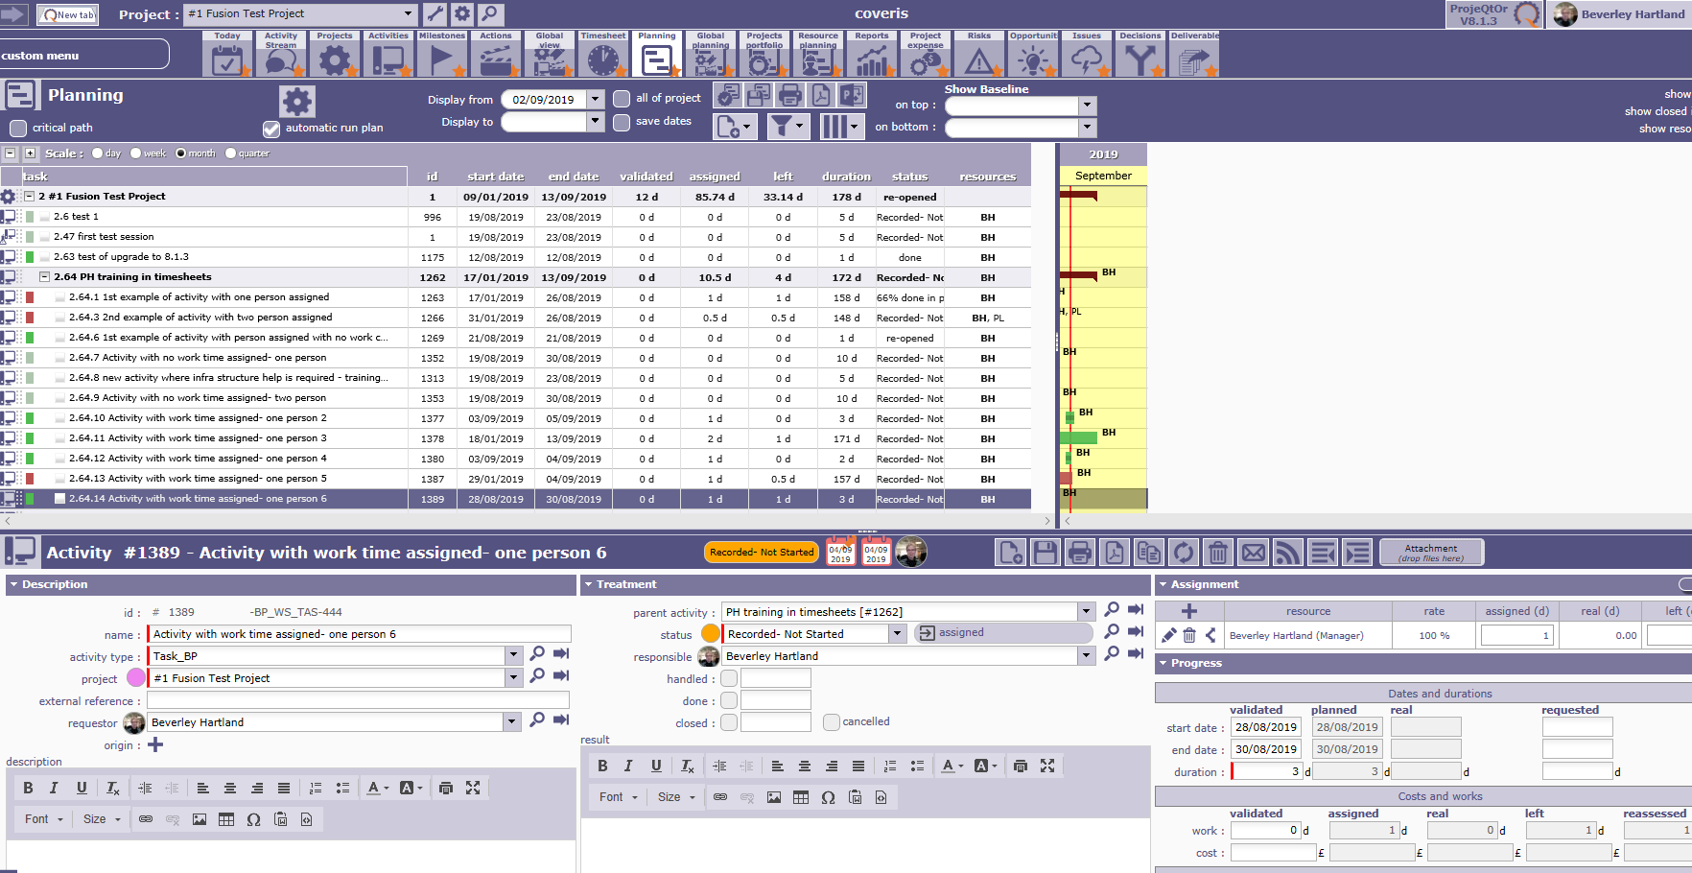

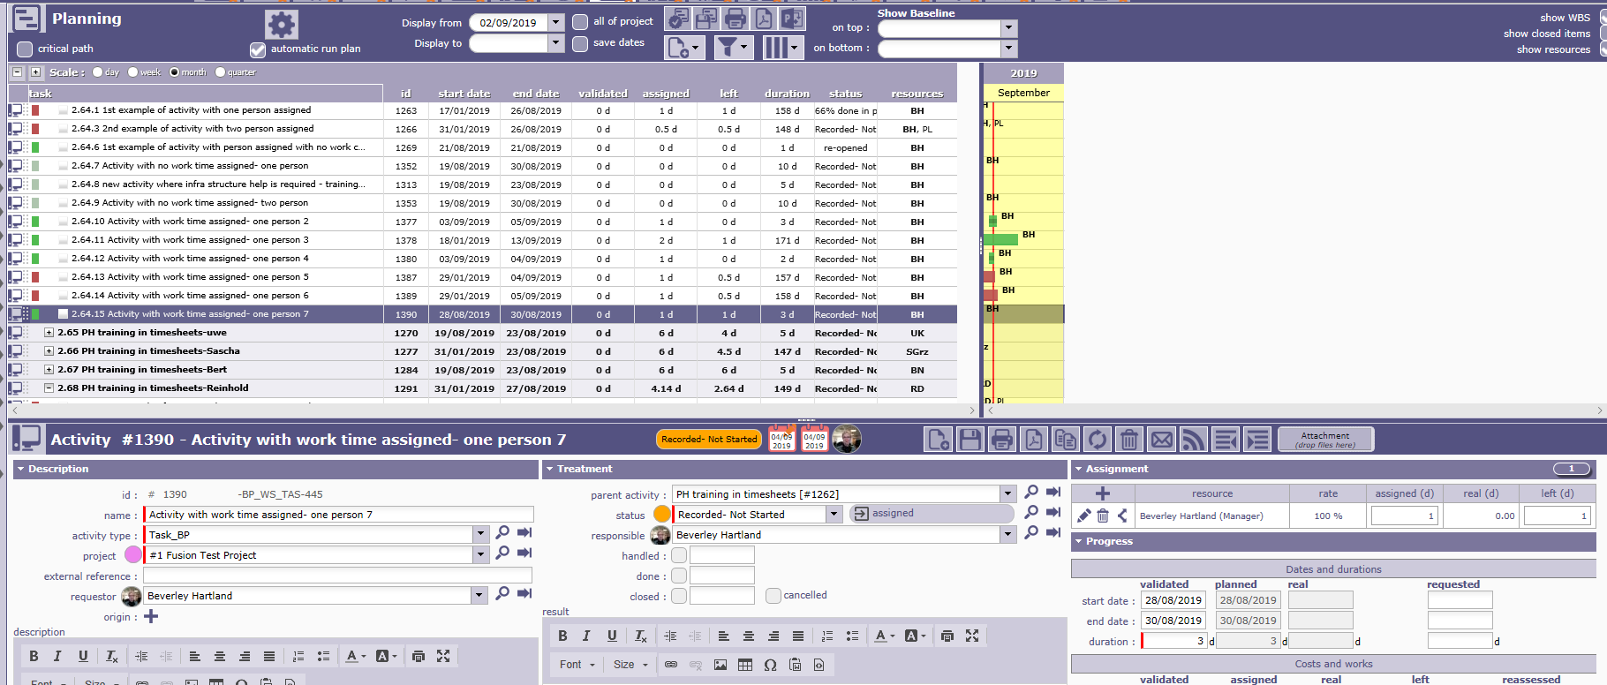
This created as expected planned and start dates of 28th Aug to 30th Aug. There is no precursor or successor activities associated with this activity.
I ensured auto run plan was switched back off

On 3rd Sept, recorded start activity by recording 0.25 days work done and saved timesheet.
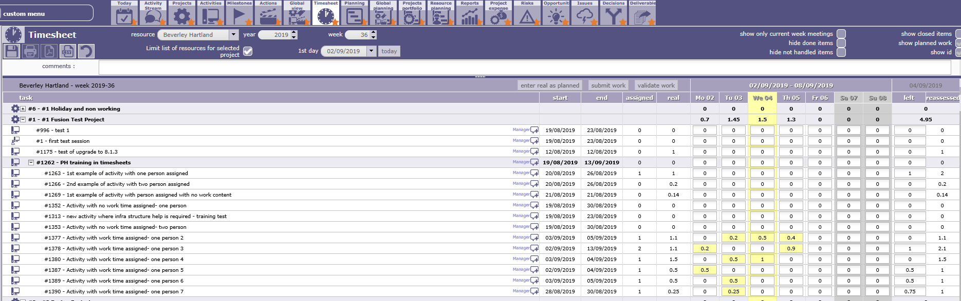
As expected the planned dates updated to 3rd Sept.
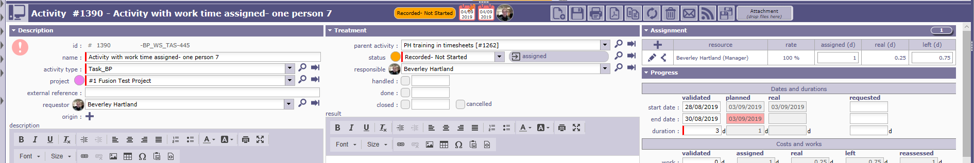
Then ran planning manually for project plan, from the start date of project as did not wish to change other planned dates.
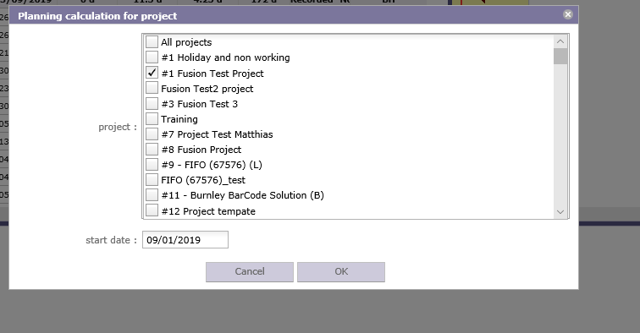

It then calculated
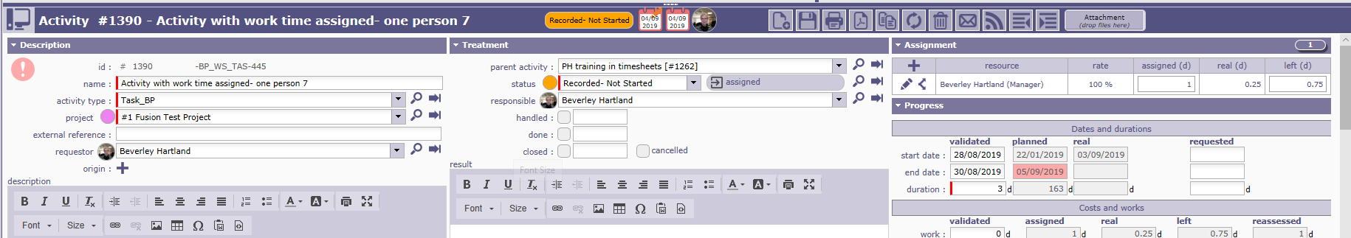
I also tried
Re-planning from 3rd September, This changed the planned dates to 22nd Jan to 1st Oct?
