Log :
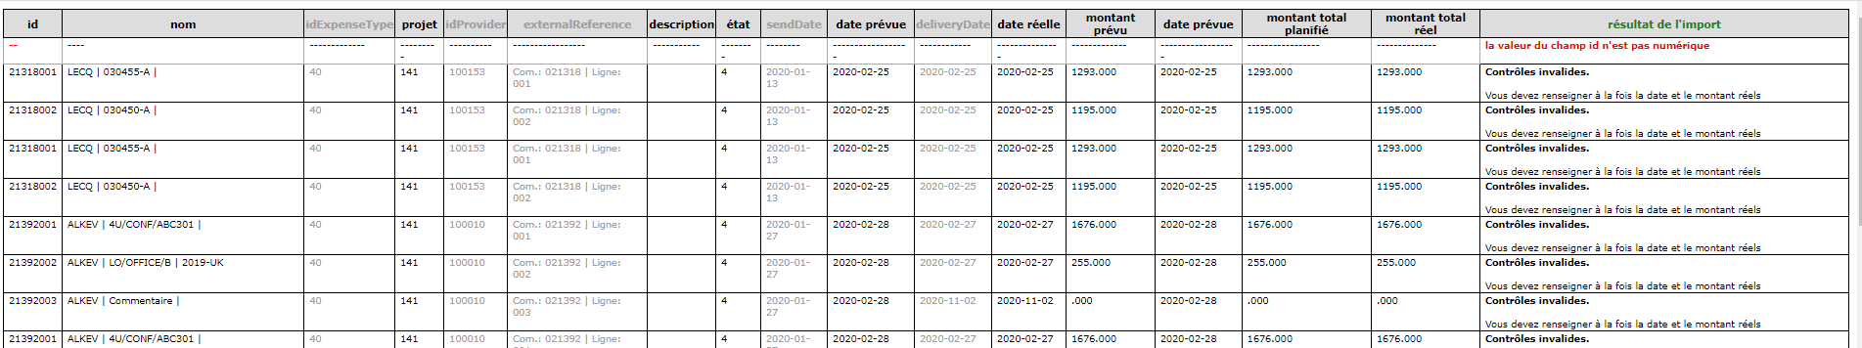
5 columm not taken into account
Previous format :
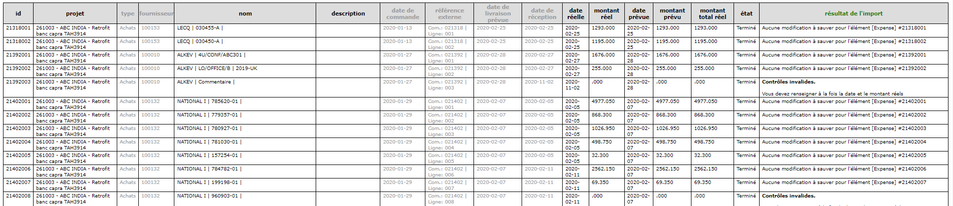
Same in fr

New SQL column name : ( as in table expense )

For individual expense same trouble in one columm

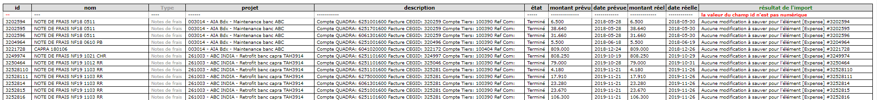
I put type in integer code … same trouble
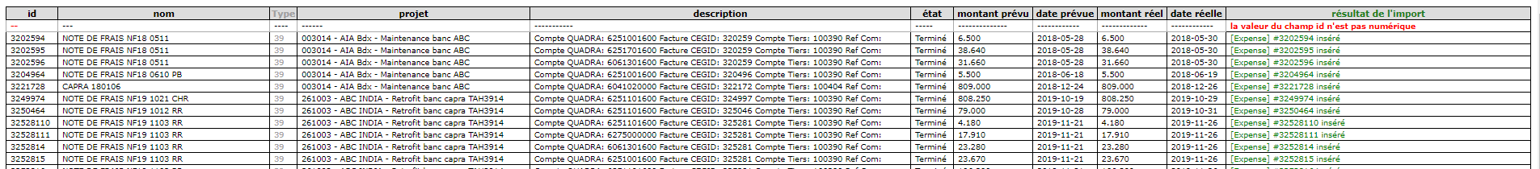
Despite information ‘datas updated’ and datas in table :
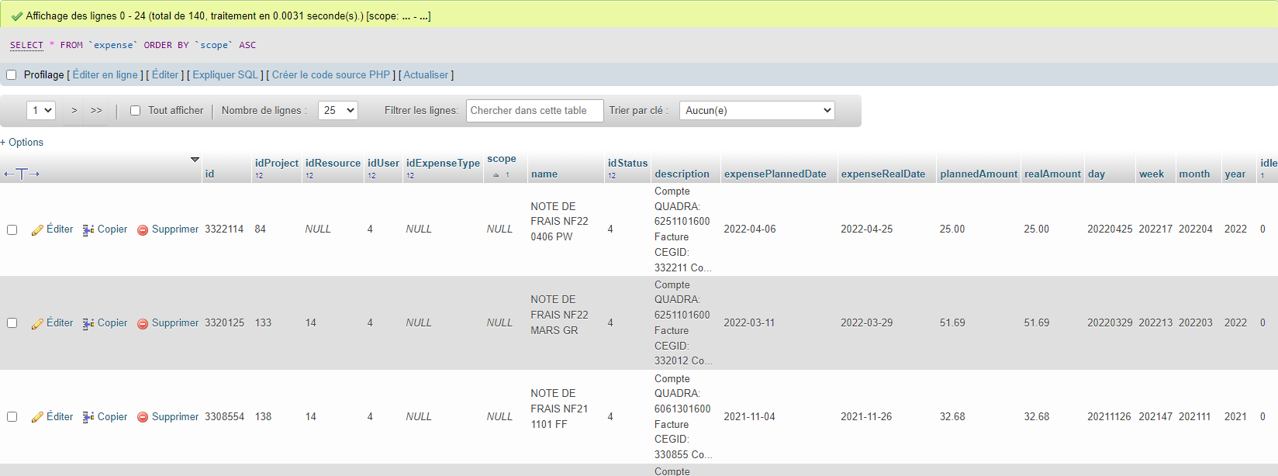
Nothing inside Projeqtor ….
